**GIT Branching**

Objective: Commit HTML, CSS & JavaScript assignments into GIT.

SECTION-1 (HTML assignments) - Steps to follow:

21. First take a backup of your assignments & projects. This is required because due to incorrect GIT operation you may lose your files.

-> All the previous version of the projects have been backed up successfully.

22. Create an empty directory ‘Assignments’ & cd to ‘Assignments’.

**Command to make a new directory:**

mkdir Assignments

**Output:**

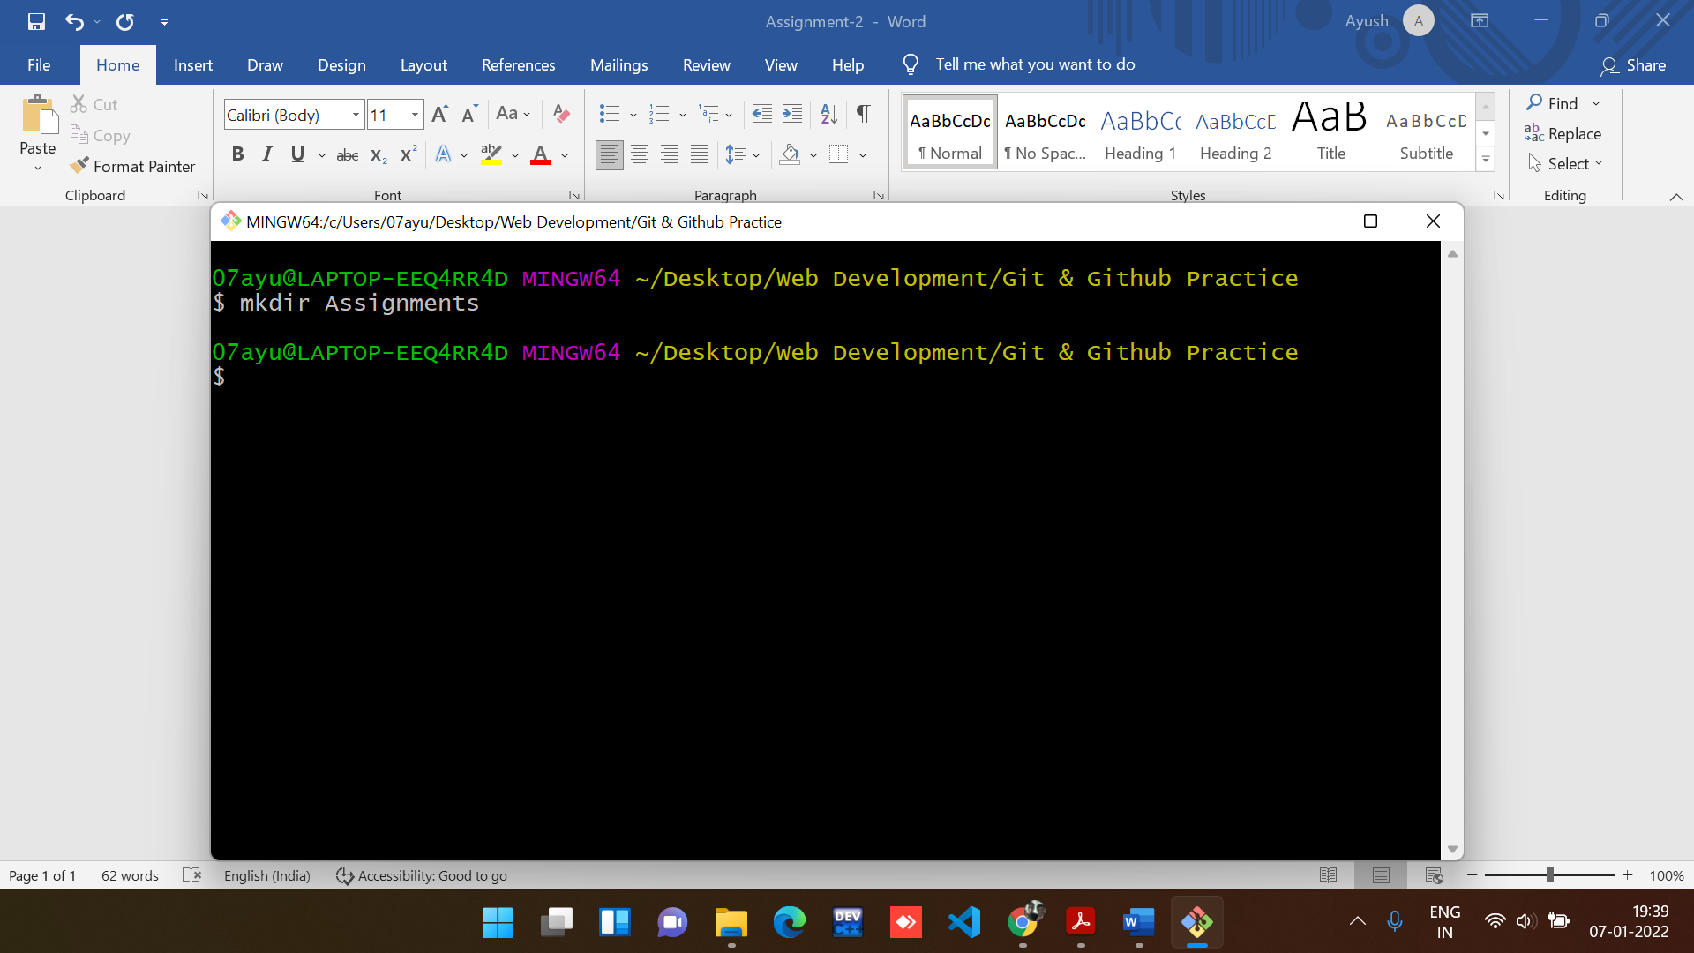

**Command to move inside a directory:**

cd Assignments

**Output:**

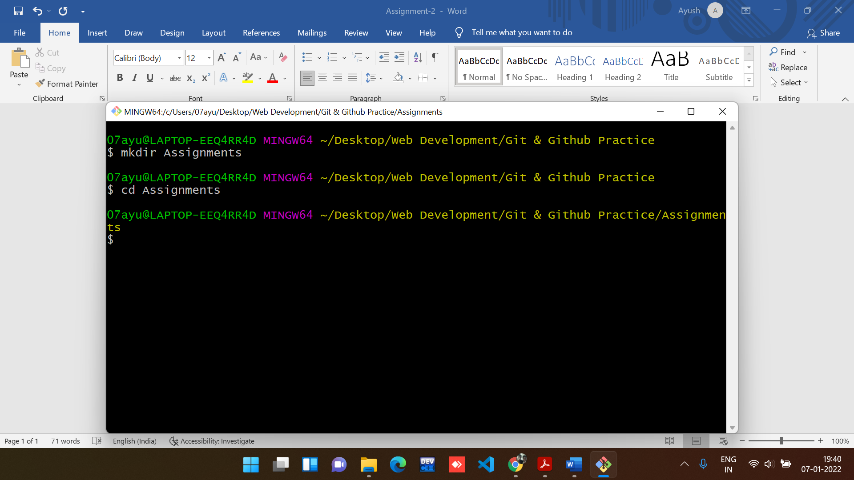

23. Create a file README.txt inside ‘Assignments’ & write few lines about the contents of ‘Assignments’ folder.

**Command to create a README.txt file:**

touch README.txt

**Output:**

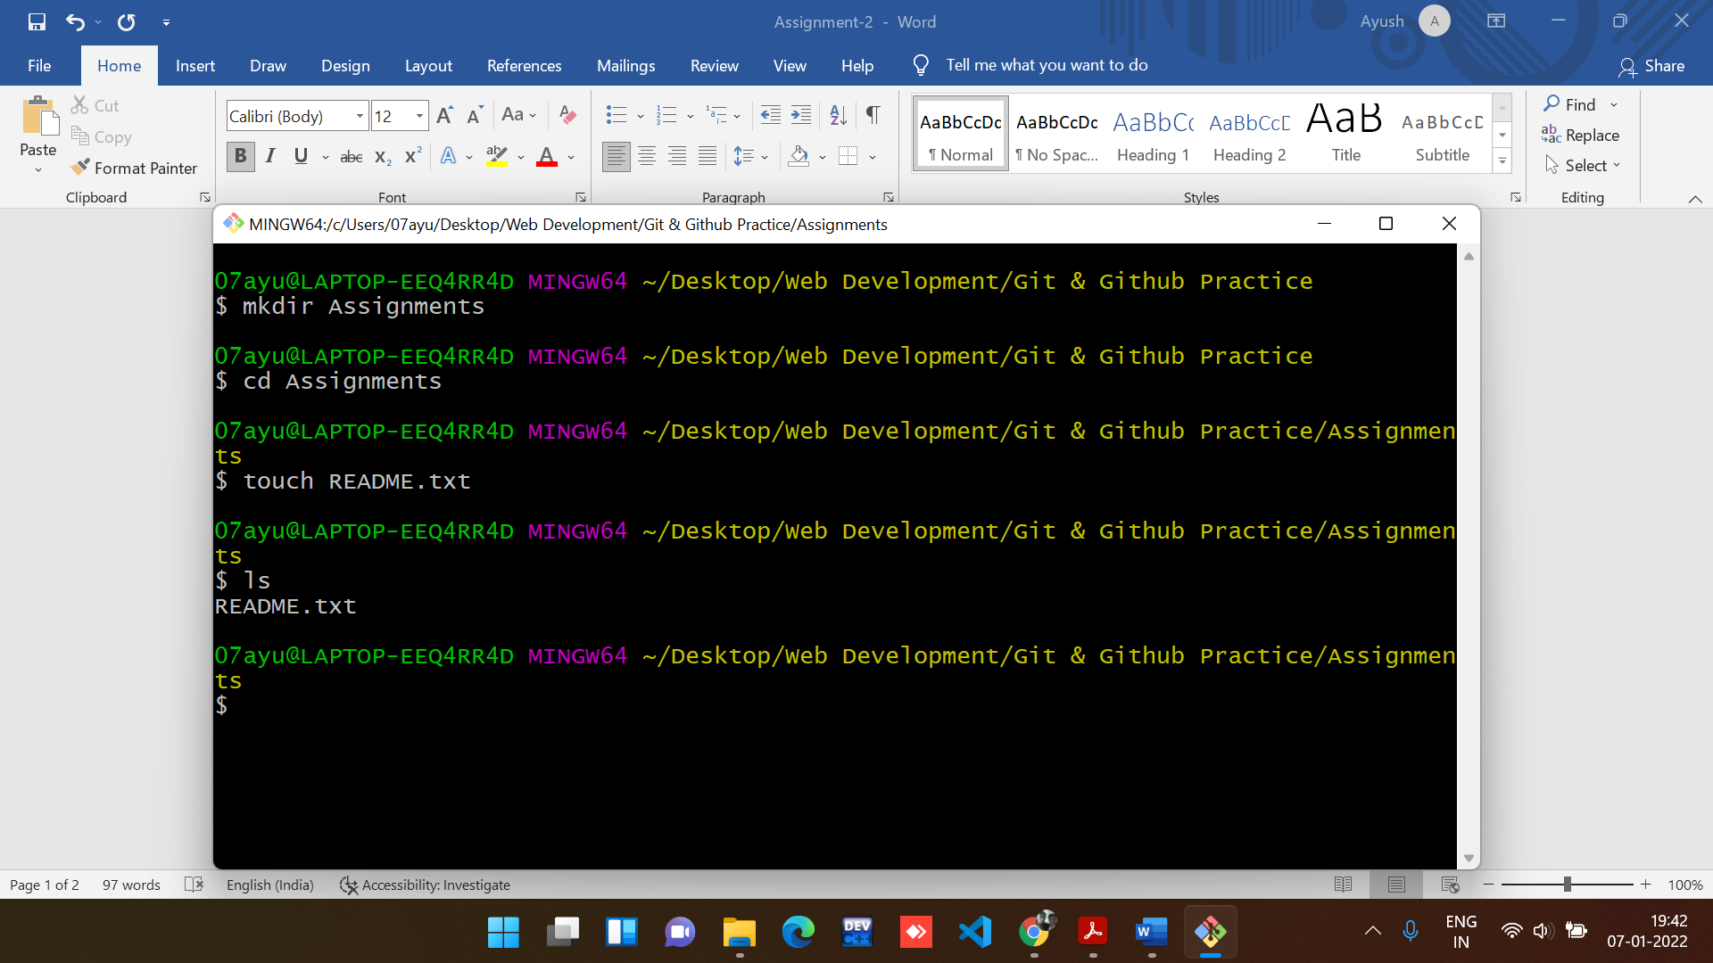

**Note: ls command is used to view files in the directory.**

**README.txt file**

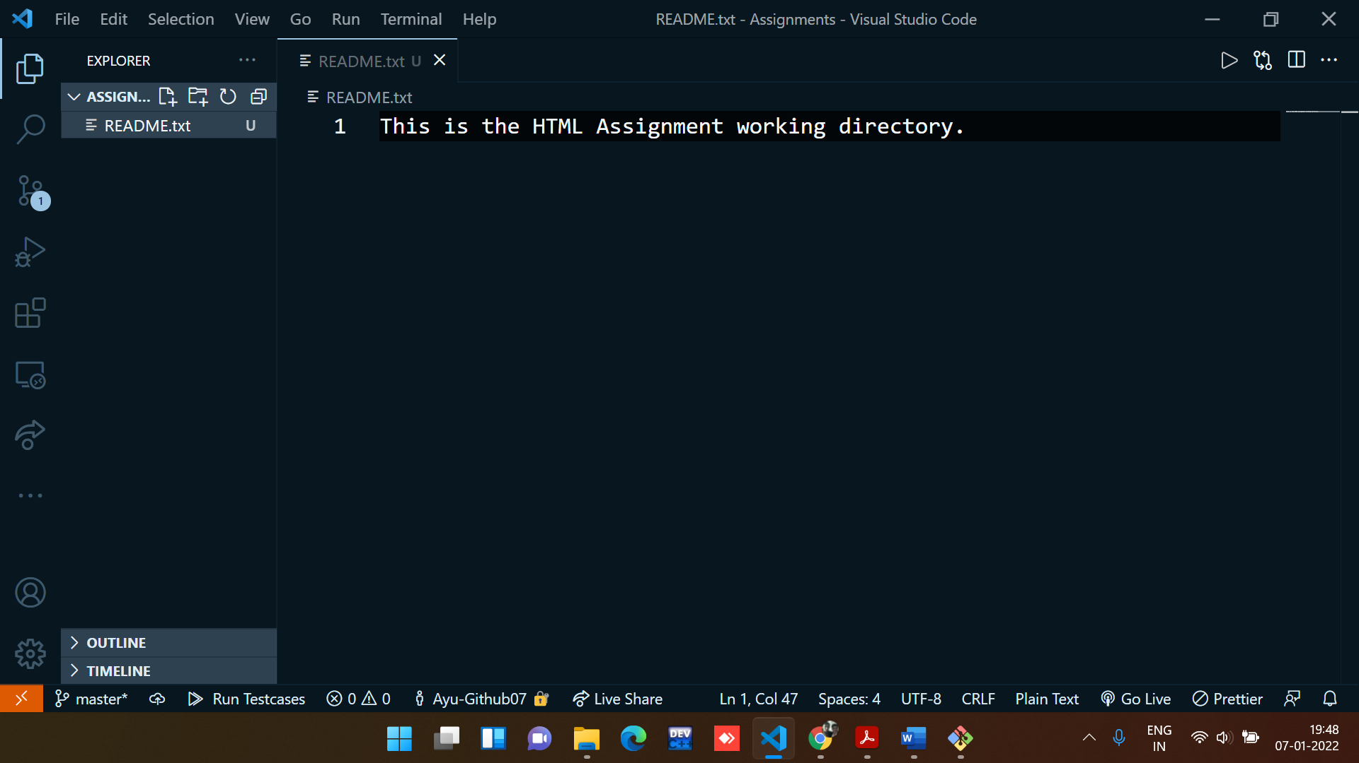

24. Commit README.txt file.

**Command for staging the file:**

git add -A

**Command for committing the file:**

git commit -m “Initial Commit”

Output:

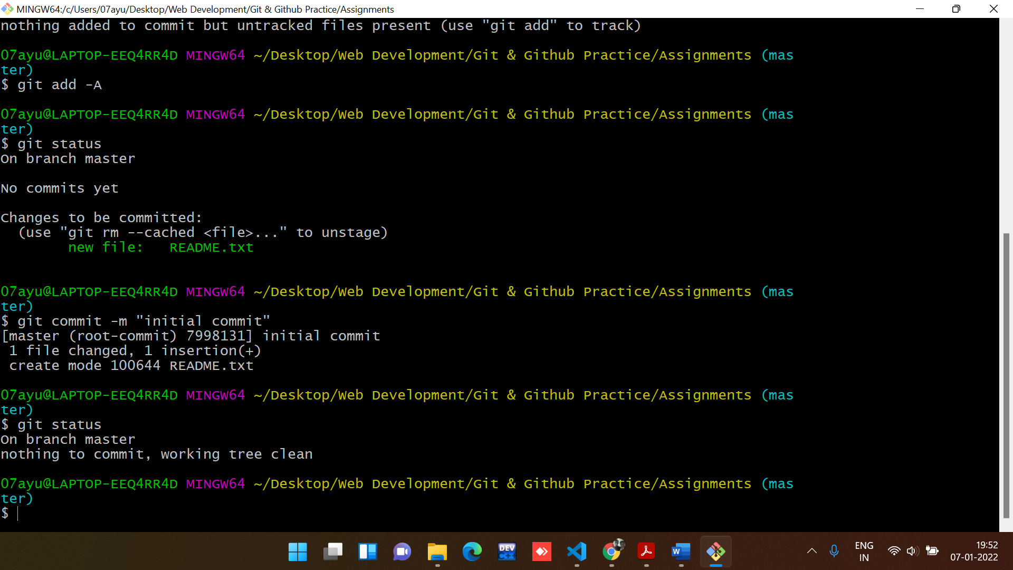

25. Now create a new branch ‘html-assignments’.

**Command for Creating a Branch:**

git branch html-assignments

**Output:**

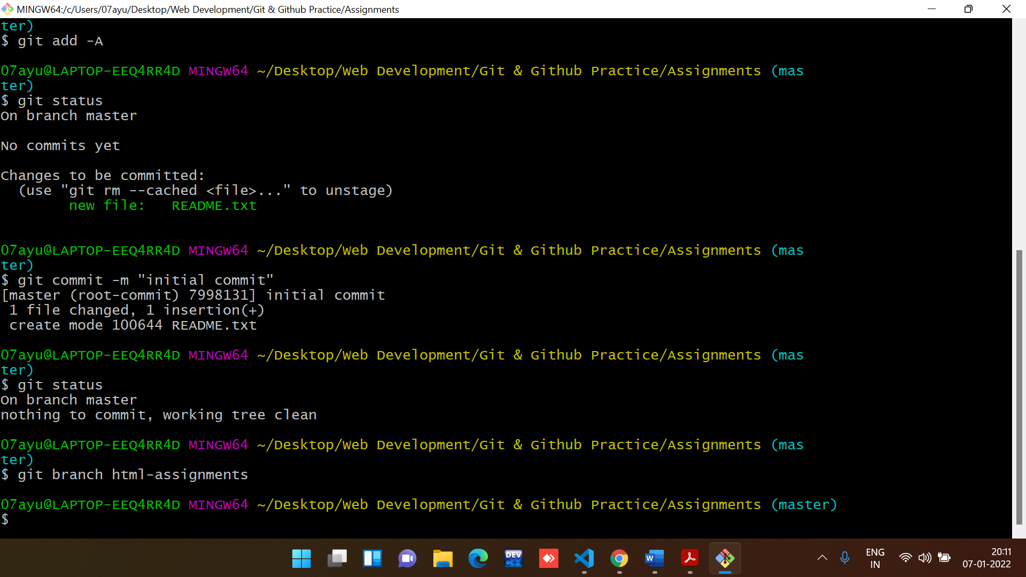

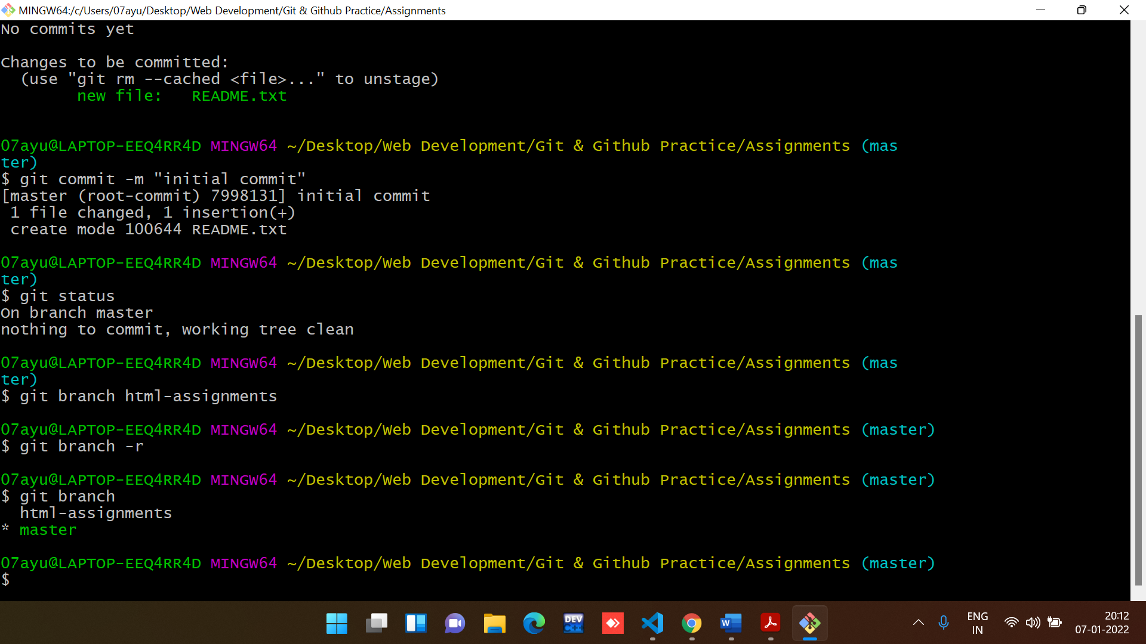

26. Switch to ‘html-assignments’ branch.

**Command for Switching a Branch (master to html-assignments):**

git checkout html-assignments

**Output:**

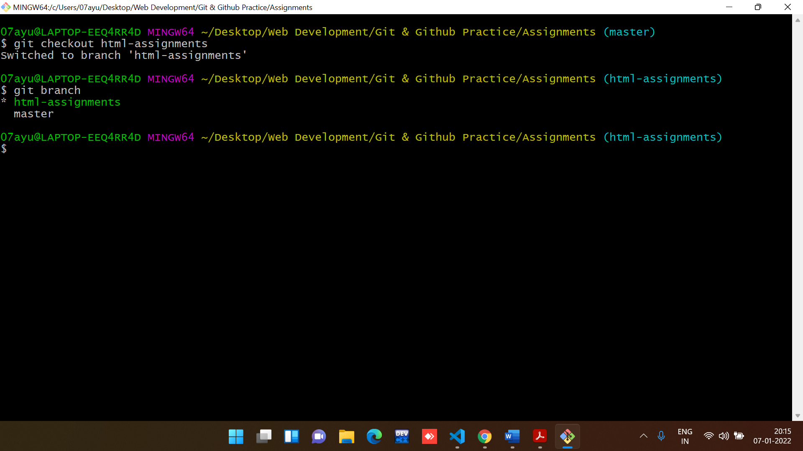

27. Copy all HTML assignments inside ‘Assignments’ folder.

Copied all the HTML files in the Assignment folder

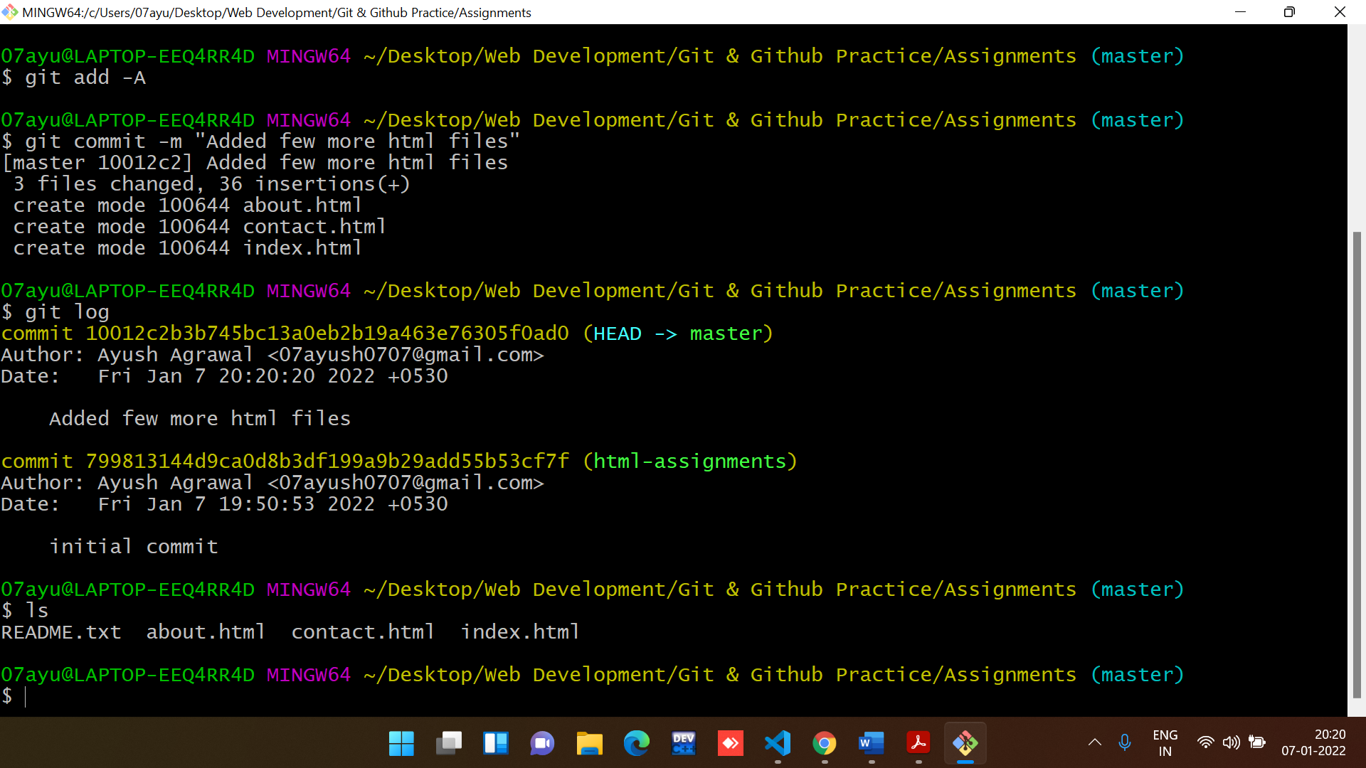

28. Commit HTML assignments into ‘html-assignments’ branch.

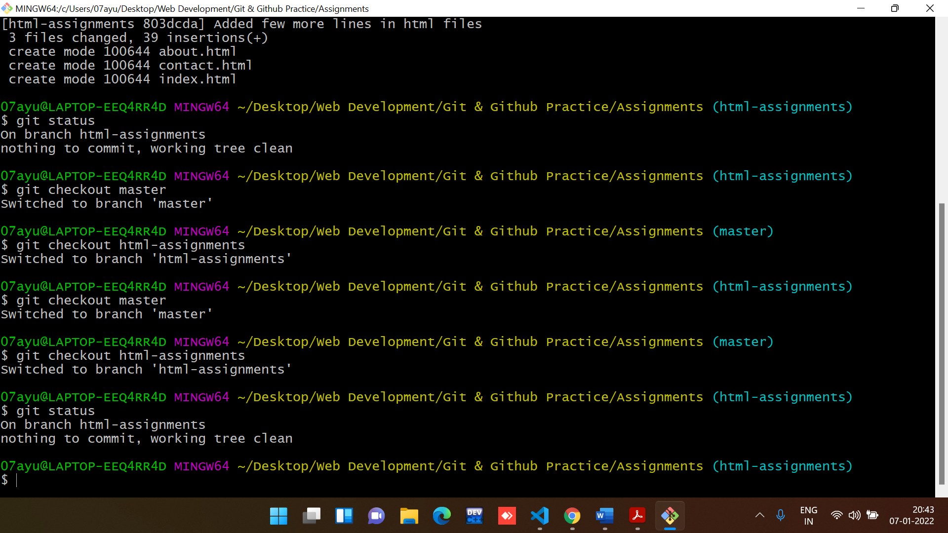

29. Make minor changes into few files belonging to ‘html-assignments’ branch.

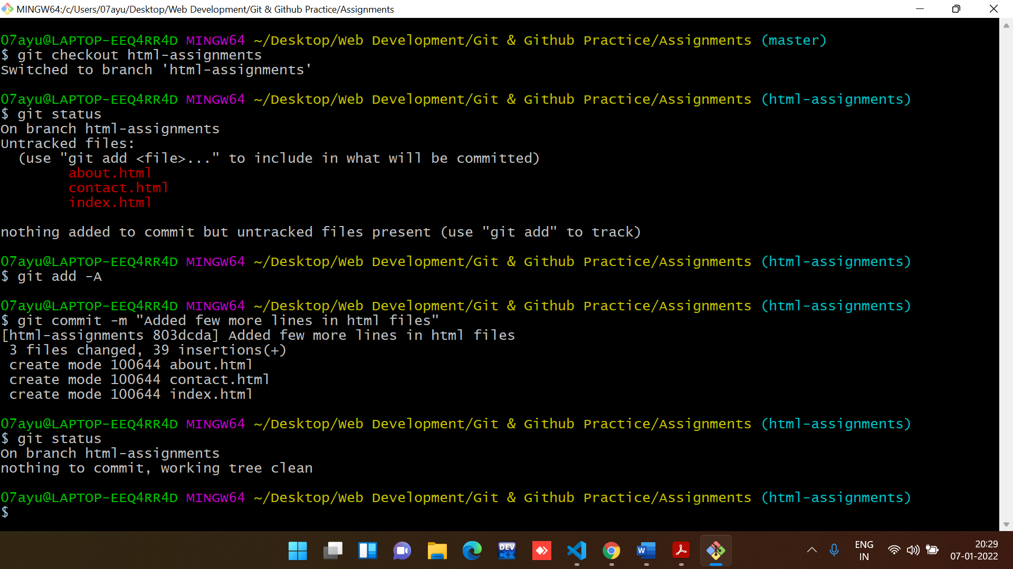

30. Commit those changed files.

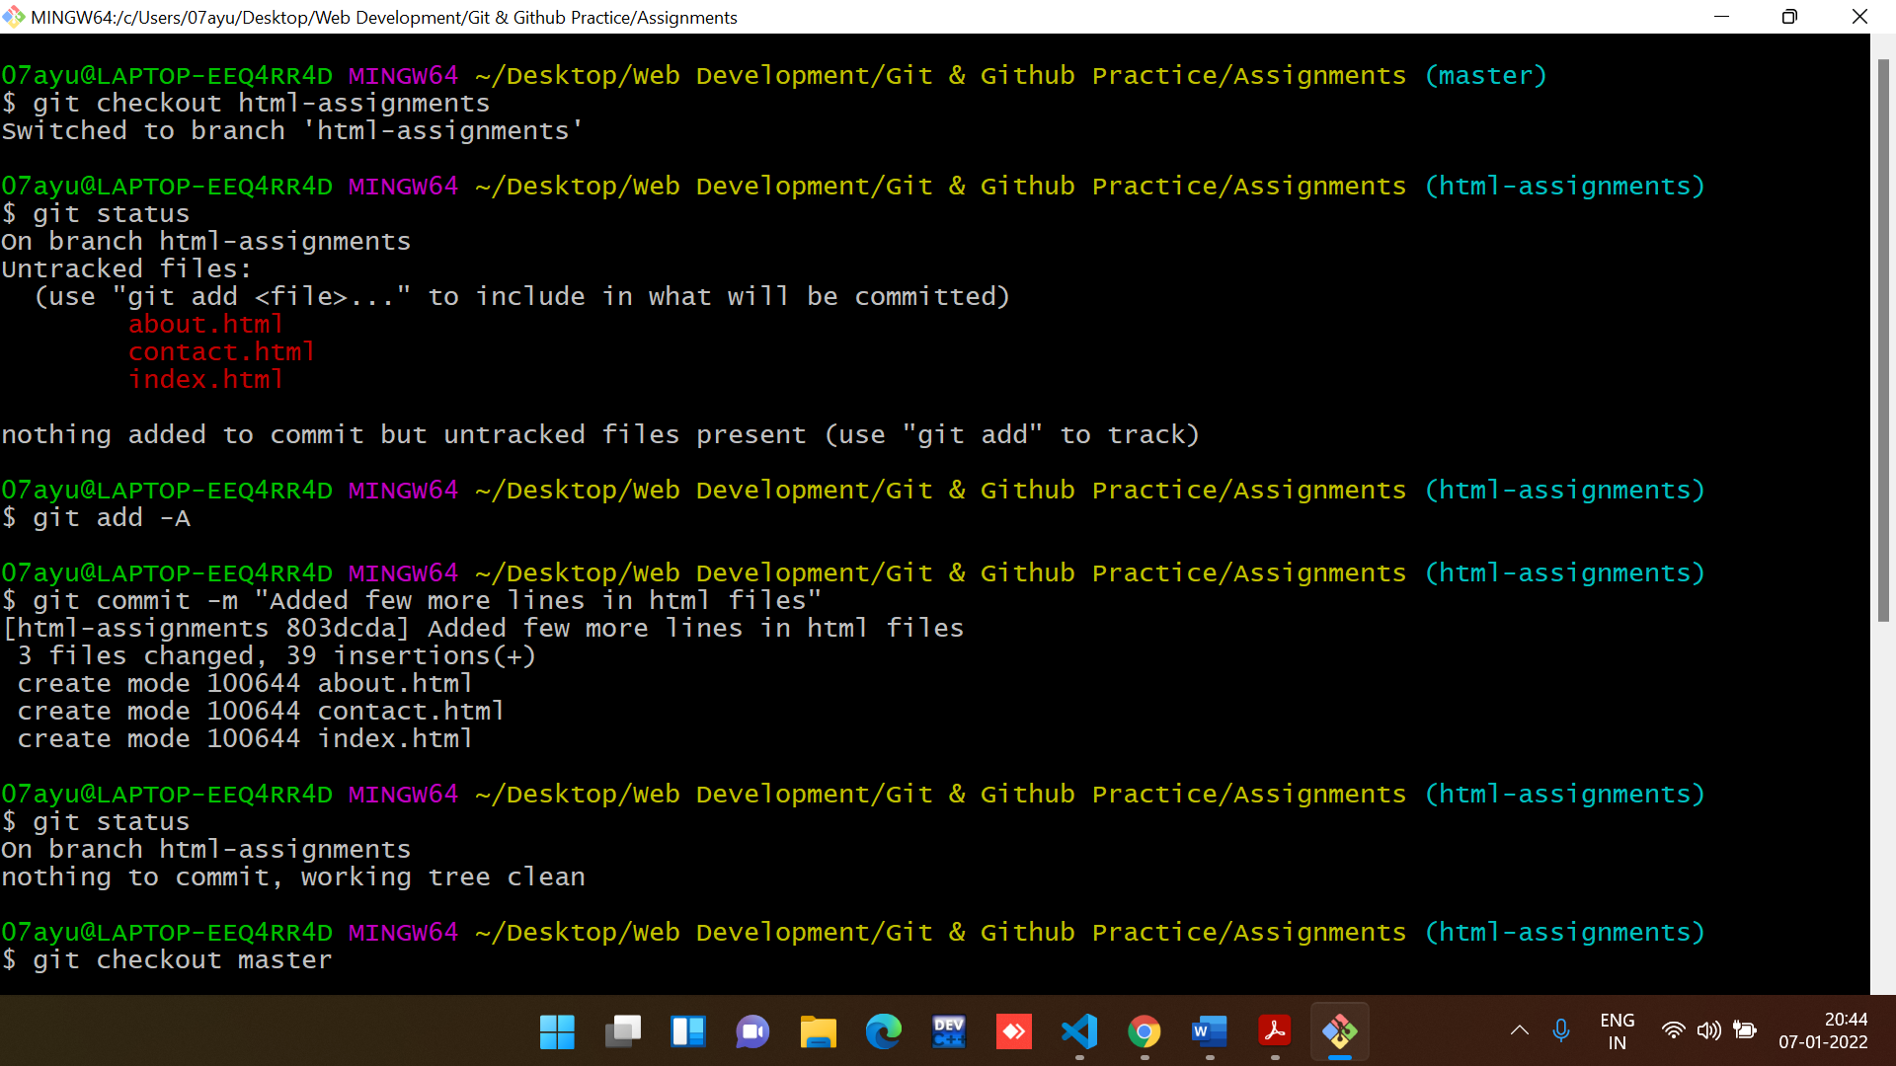

31. Switch to master branch.

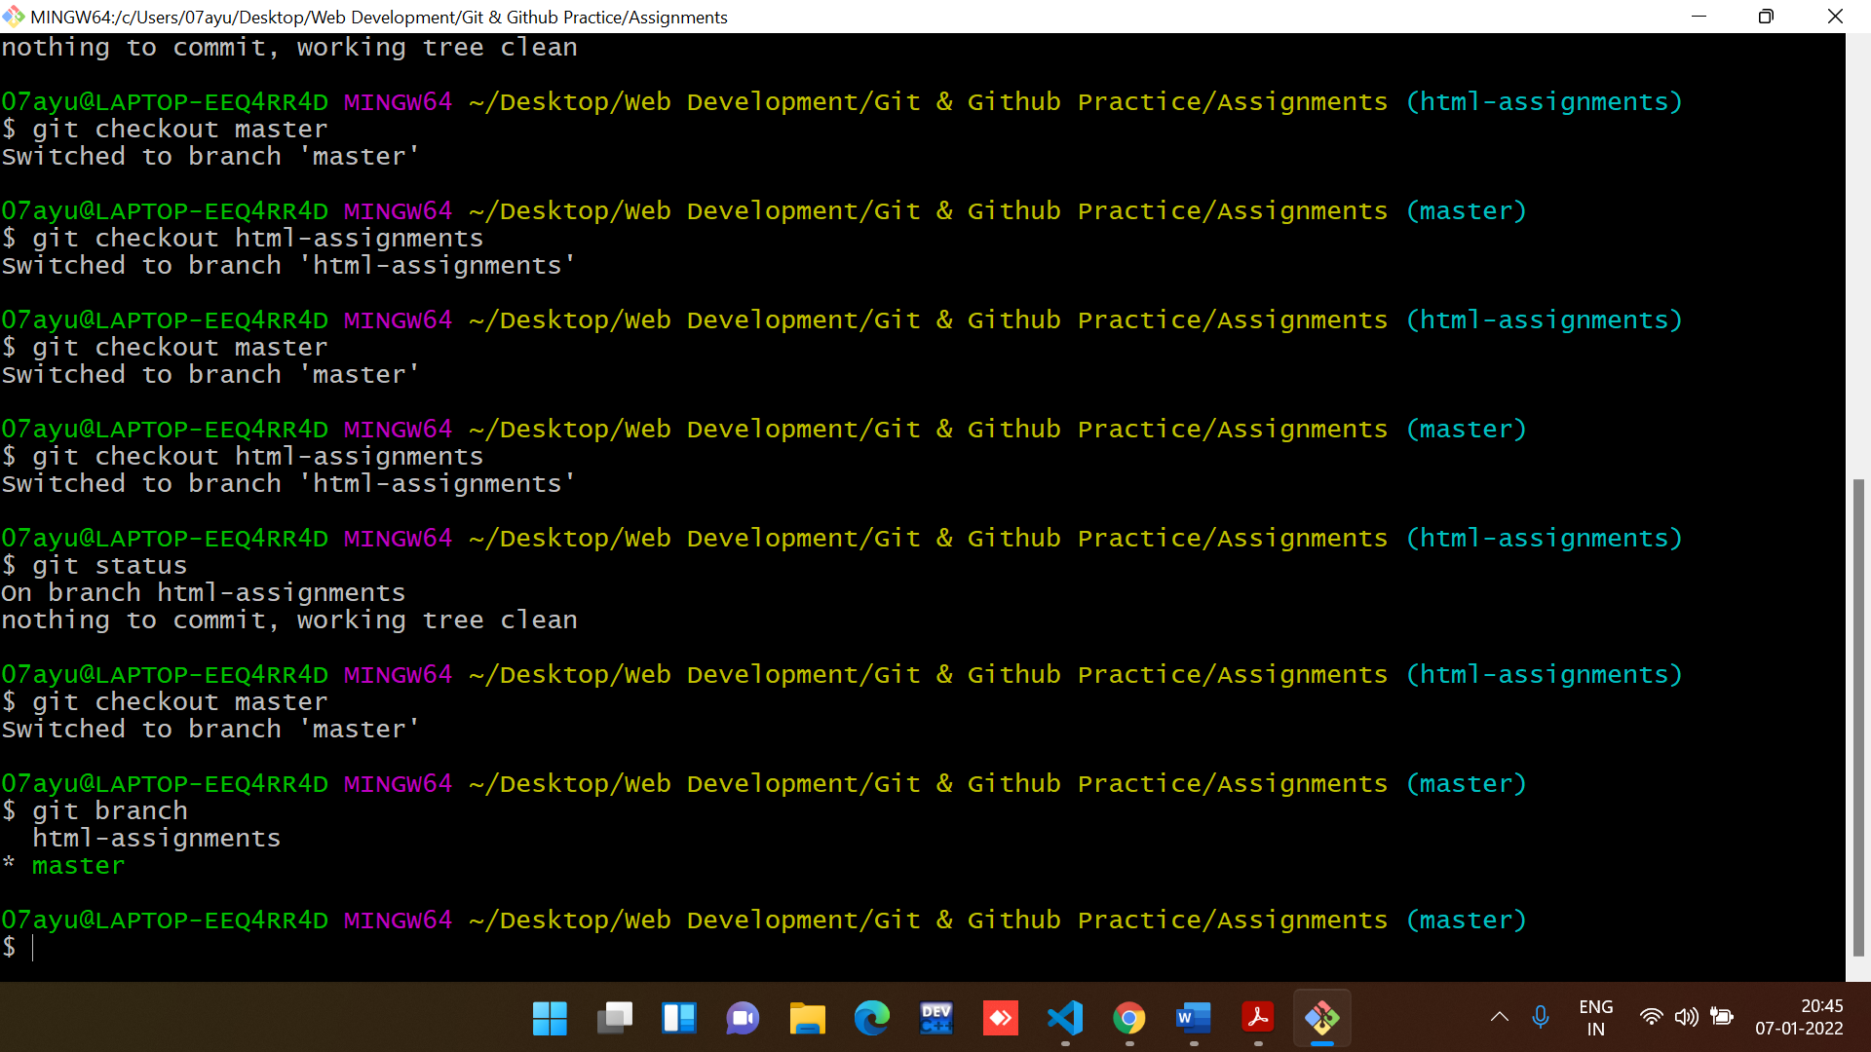

32. Make minor changes into README.txt file & commit those changes into master.

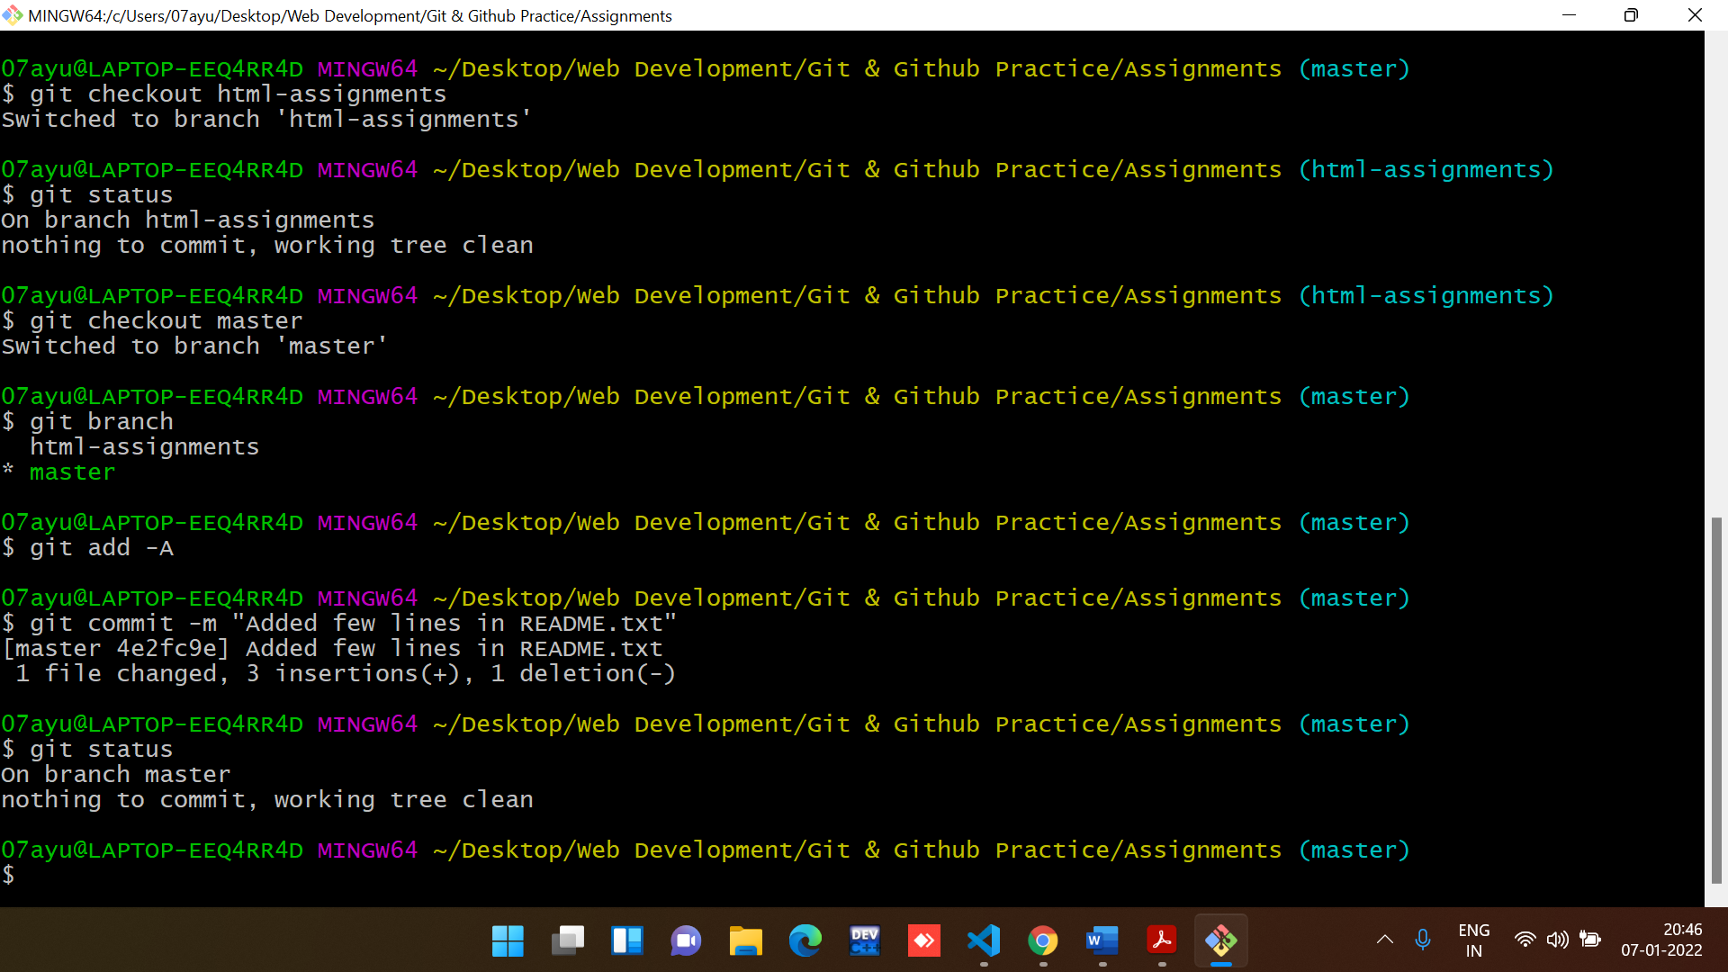

33. Again switch to ‘html-assignments’ branch.

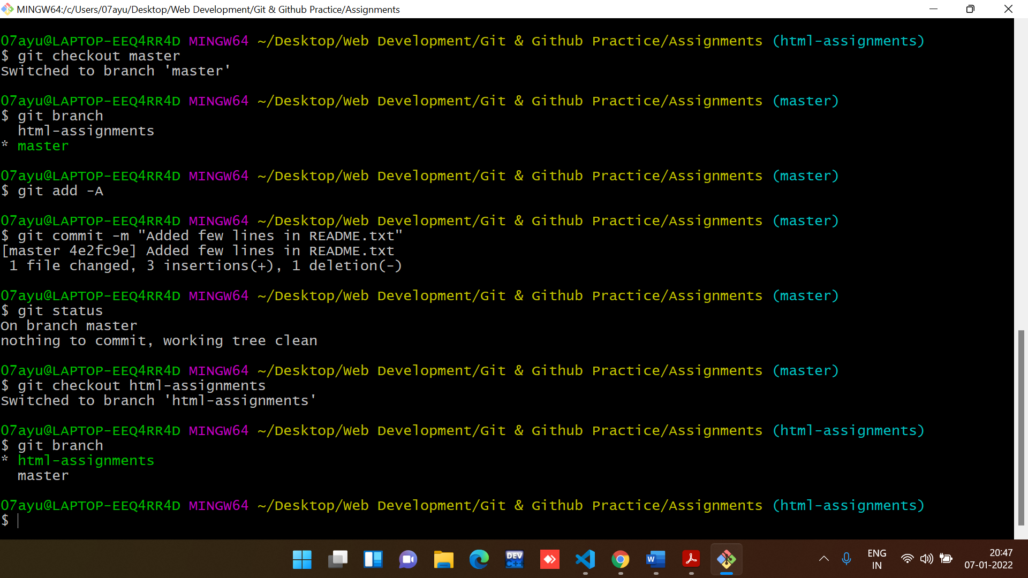

34. Make minor changes into few files belonging to ‘html-assignments’ branch.

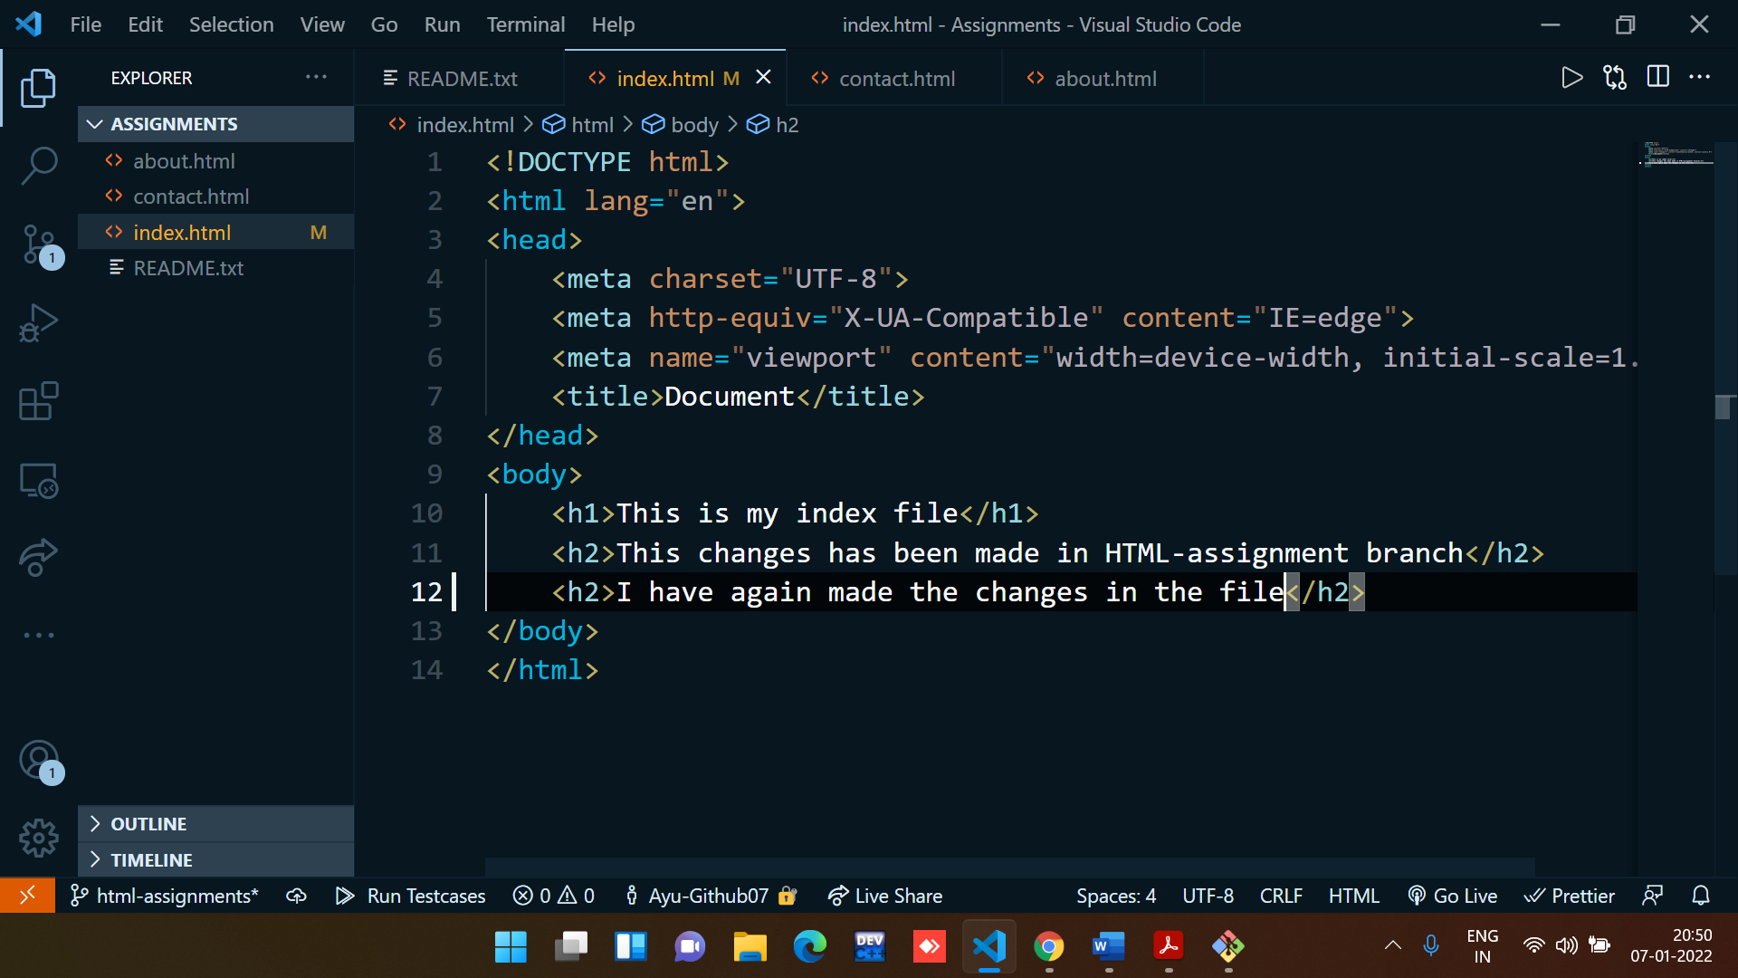

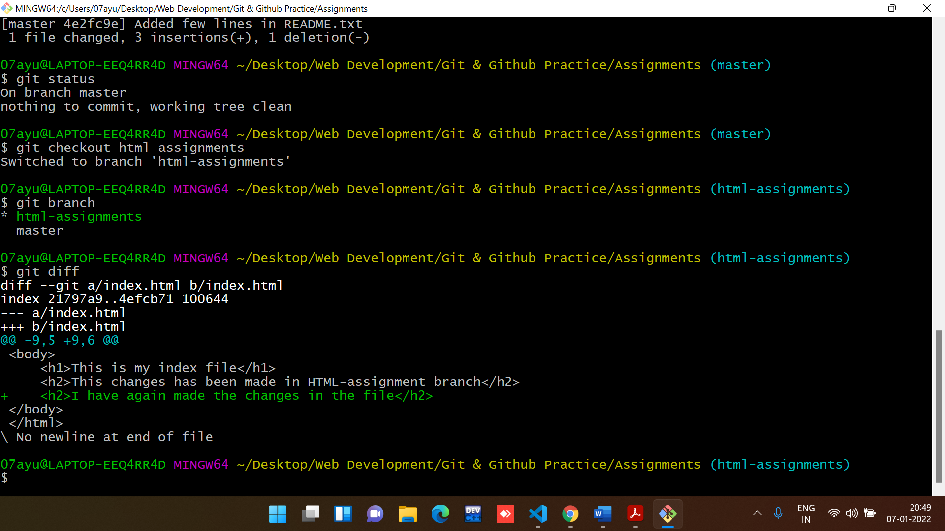

35. Commit those changes.

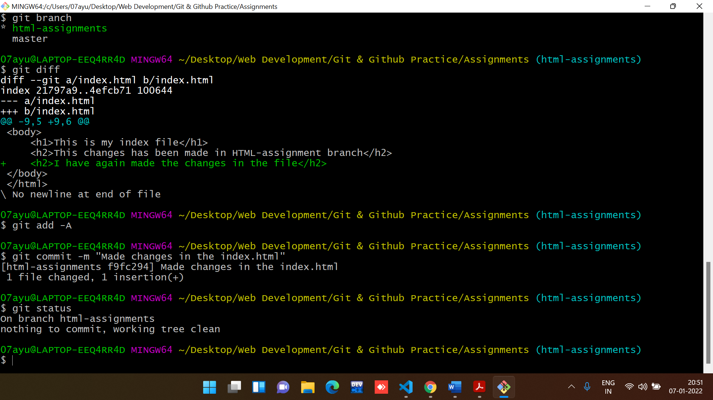

36. Switch to master.

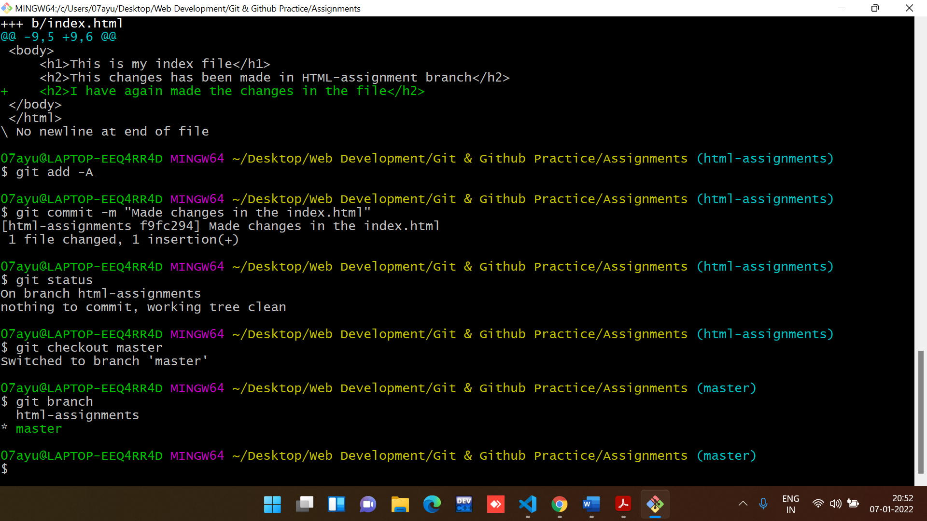

37. Merge ‘html-assignments’ branch into master. Confirm all html assignments are shown in master.

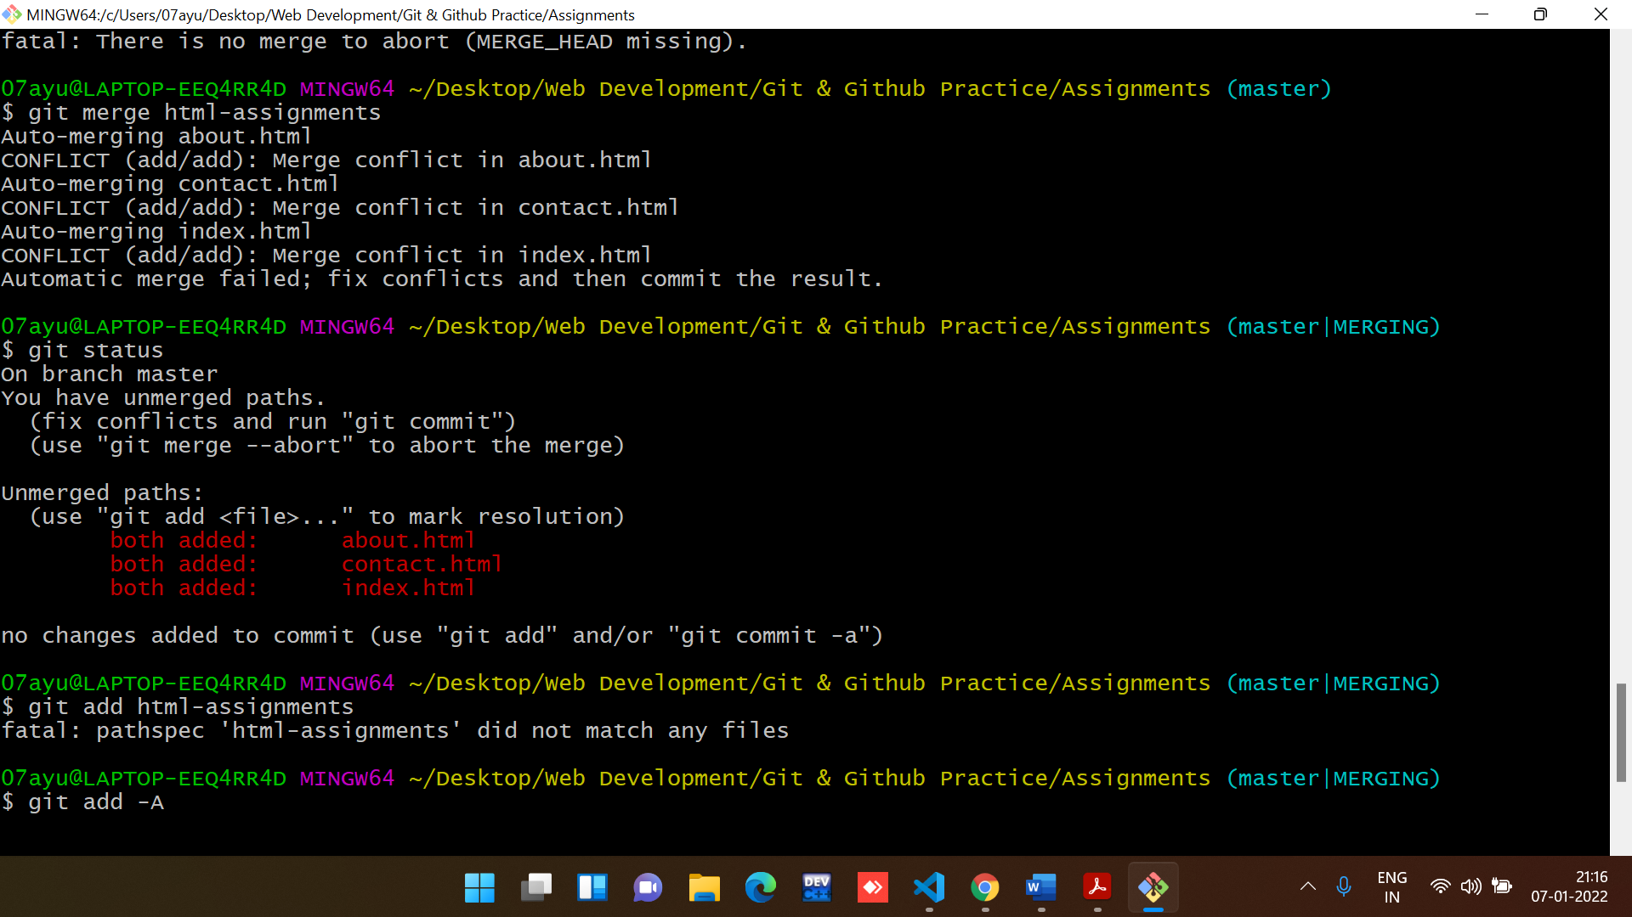

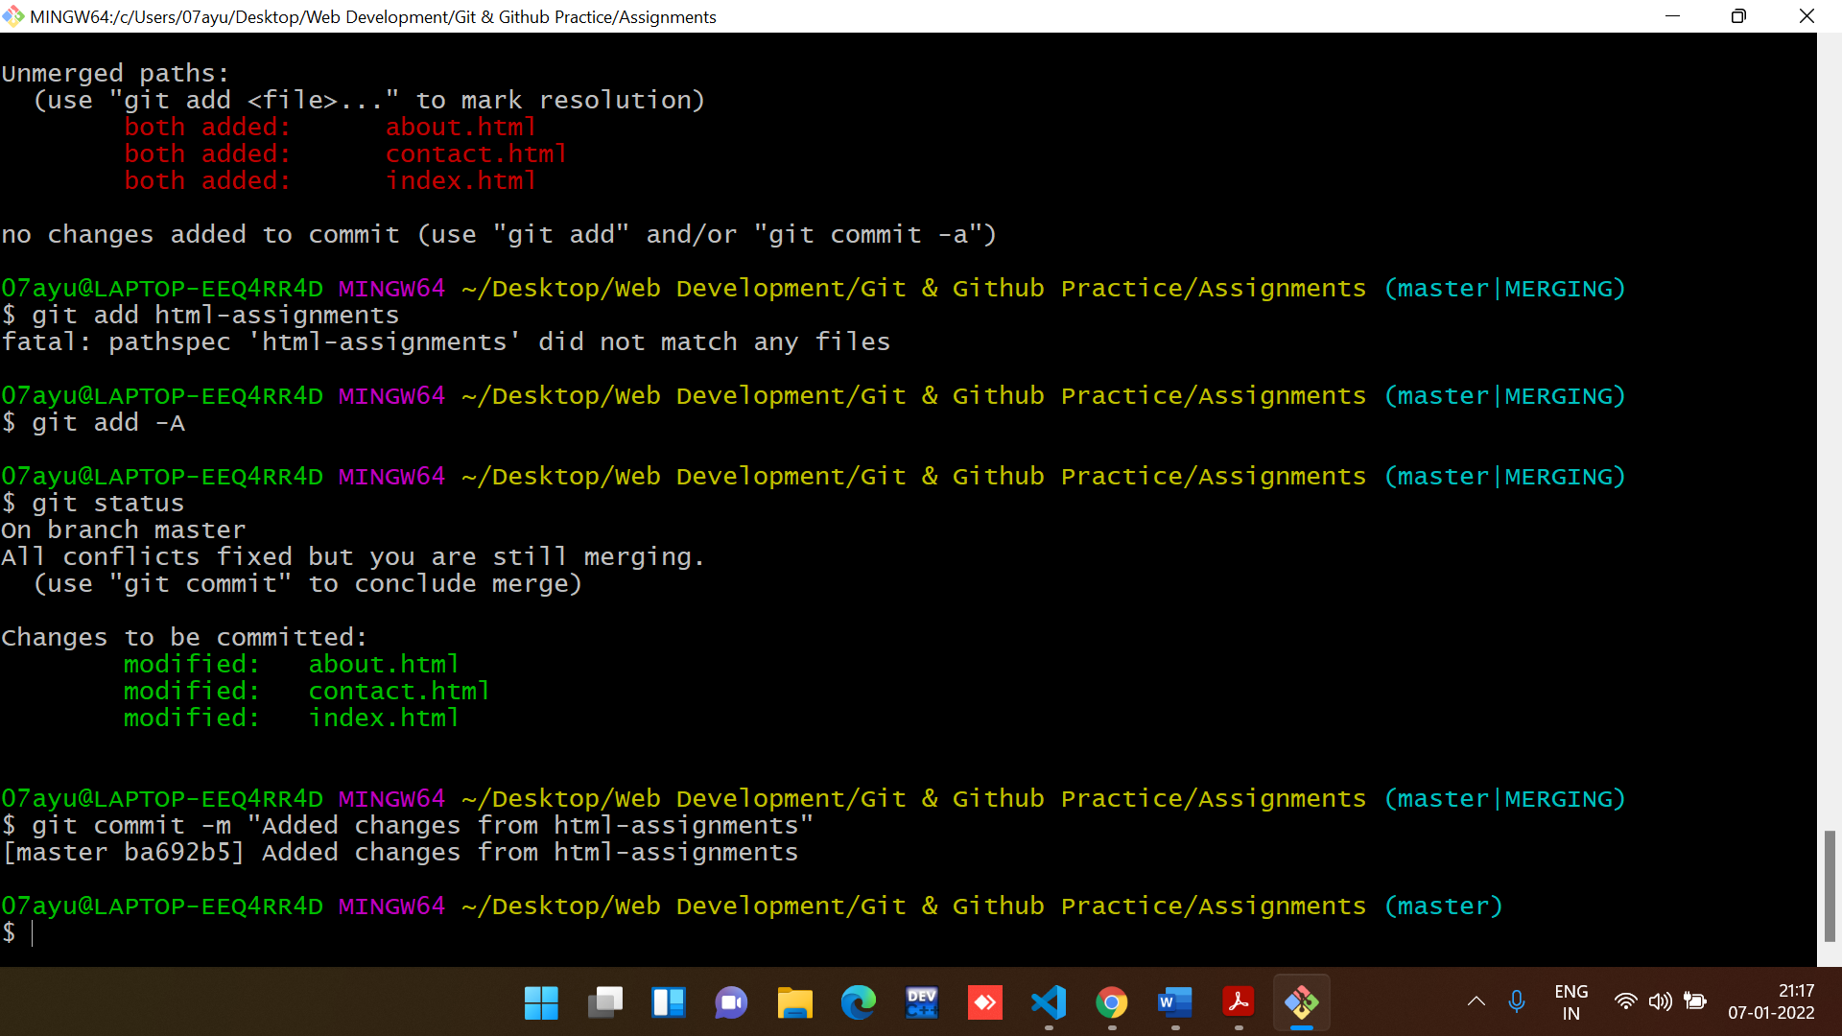

38. Finally delete the ‘html-assignments’ branch.

